7778 Vance Drive Arvada, CO 80003
P: 303-420-4422, F: 303-420-4681 E: welcome@indiantreeanimalhospital.com
www.indiantreeanimalhospital.com

Introducing a New Dog to Other Dogs

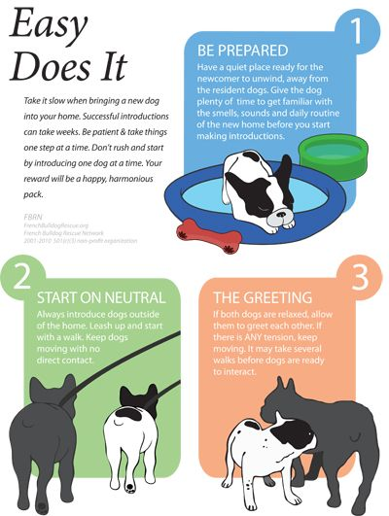
From “the leader of the pack” to “the top dog,” plenty of simplistic metaphors come from the canine world. But relationships between canines can be pretty complex, beginning with the very first meeting.

Like most animals who live in groups, dogs establish their own social structure, sometimes called a dominance hierarchy. This dominance hierarchy serves to maintain order, reduce conflict and promote cooperation among pack members.

Dogs also establish territories, which they may defend against intruders or rivals. Of course, dogs’ social and territorial nature affects their behavior whenever a new dog is introduced to the household.

Choose a Neutral Location

Introduce the dogs in a neutral location so that your resident dog is less likely to view the newcomer as a territorial intruder. Each dog should be handled by a separate person. With both dogs on leashes, begin the introductions in an area unfamiliar to each, such as a park or a neighbor’s yard. If you frequently walk your resident dog in a nearby park, he/she may view that area as her territory, too, so choose a less familiar site. If you are adopting your dog from an animal shelter, you might even bring your resident dog to the local shelter and introduce the two there (some shelters may even require that a new dog meets the resident dog before the adoption is complete).

Use Positive Reinforcement

From the first meeting, help both dogs experience “good things” when they’re in each other’s presence. Let them sniff each other briefly, which is normal canine greeting behavior. As they do, talk to them in a happy, friendly tone of voice; never use a threatening tone. (Don’t allow them to investigate and sniff each other for too long, however, as this may escalate to an aggressive response.)

After a short time, get the attention of both dogs and give each a treat in return for obeying a simple command, such as “sit” or “stay.” Take the dogs for a walk and let them sniff and investigate each other at intervals. Continue with the “happy talk,” food rewards, and simple commands.

Be Aware of Body Postures
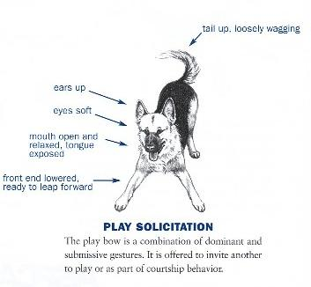
One body posture that indicates things are going well is a “play-bow.” One dog will crouch with her/his front legs on the ground and her/his hind end in the air. This is an invitation to play, and a posture that usually elicits friendly behavior from the other dog. Watch carefully for body postures that indicate an aggressive response, including hair standing up on one dog’s back, teeth-baring, deep growls, a stiff-legged gait, or a prolonged stare. If you see such postures, interrupt the interaction immediately by calmly getting each dog interested in something else.

For example, both handlers can call their dogs to them, have them sit or lie down, and reward each with a treat. The dogs’ interest in the treats should prevent the situation from escalating into aggression. Try letting the dogs interact again, but this time for a shorter time period and/or at a greater distance from each other.

Taking the Dogs Home

When the dogs seem to be tolerating each other’s presence without fearful or aggressive responses, and the investigative greeting behaviors have tapered off, you can take them home. Whether you choose to take them in the same vehicle will depend on their size, how well they ride in the car, how trouble-free the initial introduction has been, and how many dogs are involved.

If you have more than one resident dog in your household, it may be best to introduce the resident dogs to the new dog one at a time. Two or more resident dogs may have a tendency to “gang up” on the newcomer.

It is important to support the dominant dog in your household, even if that turns out to be the newcomer. This may mean, for example, allowing the dominant dog to claim a special toy or favored sleeping spot as his/her own. Trying to impose preference for which dog should be dominant can confuse the dogs and create further problems.

Introducing Puppies to Adult Dogs

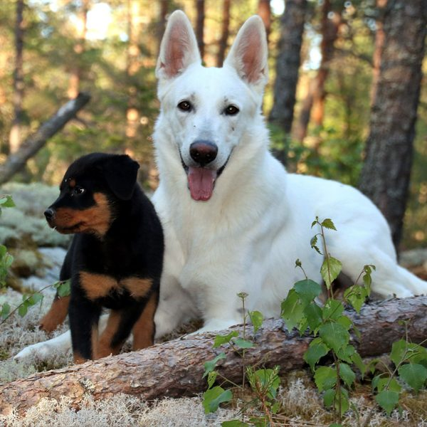
Puppies usually pester adult dogs unmercifully. Before the age of four months, puppies may not recognize subtle body postures from adult dogs signaling that they’ve had enough. Well-socialized adult dogs with good temperaments may set limits with puppies with a warning growl or snarl. These behaviors are normal and should be allowed.

Adult dogs who aren’t well-socialized, or who have a history of fighting with other dogs, may attempt to set limits with more aggressive behaviors, such as biting, which could harm the puppy. For this reason, a puppy shouldn’t be left alone with an adult dog until you’re confident the puppy isn’t in any danger. Be sure to give the adult dog some quiet time away from the puppy, and some extra individual attention as well.

When to Get Help

If the introductions don’t go smoothly, contact a professional animal behaviorist immediately. Dogs can be severely injured in fights, and the longer the problem continues, the harder it can be to resolve. Punishment won’t work, and could make things worse. Fortunately, most conflicts between dogs in the same family can be resolved with professional guidance.

Ask our team for help and behaviorist recommendations.

